POWER BI WEEK 6 PROJECT REPORT

Healthcare Data Analysis Dashboard

NAME: KEERTHANA R

DEPARTMENT: BSC DS AND AI

1. Introduction

In Week 6, an interactive healthcare dashboard was created using Microsoft Power BI. The dashboard was developed using the data model and DAX measures prepared in Week 5. It provides a clear view of hospital admissions, billing, patient demographics, medical conditions, and admission trends.

2. Dashboard Components

The dashboard contains four KPI Cards, one Stacked Bar Chart, one Scatter Chart, one Donut Chart, one Line Chart, and one Slicer.

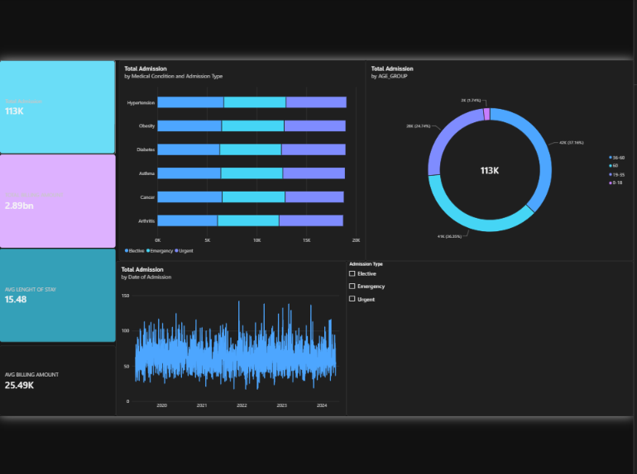

3. KPI Cards

**Total Admissions:**
This card displays the total number of hospital admissions in the healthcare dataset.

**Total Billing Amount:**
This card shows the overall billing amount generated from the hospital records.

**Average Billing Amount:**
This card represents the average billing amount for the recorded hospital admissions.

**Average Length of Stay:**
This card displays the average number of days patients stayed in the hospital.
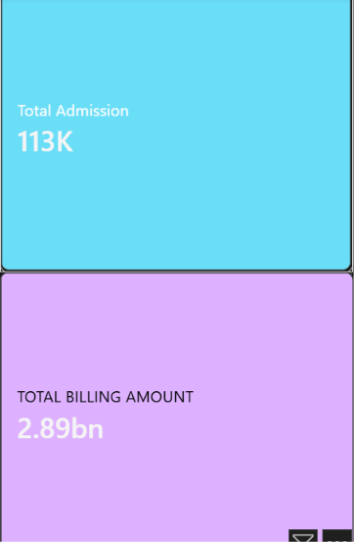
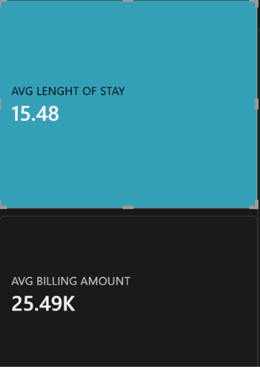

4. Stacked Bar Chart – Medical Condition and Admission Type

The Stacked Bar Chart is used to compare hospital admissions across different medical conditions.

* **Y-Axis:** Medical Condition
* **X-Axis:** Total Admissions
* **Legend:** Admission Type

This visual helps identify the number of admissions for each medical condition and shows how different admission types contribute to the total. 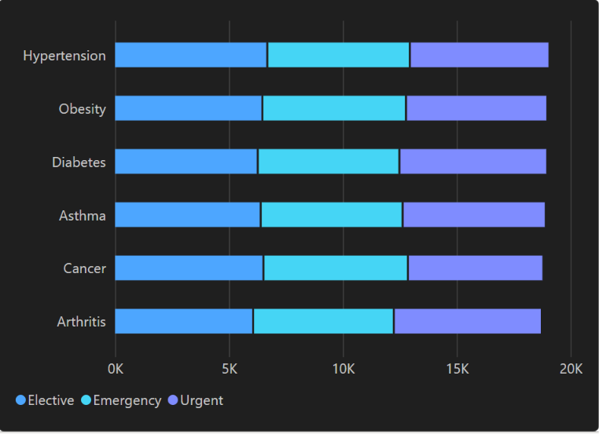

5. Donut Chart – Age Group Distribution

The Donut Chart is used to show the distribution of patients across different age groups.

* **Legend:** Age Group
* **Values:** Total Admissions
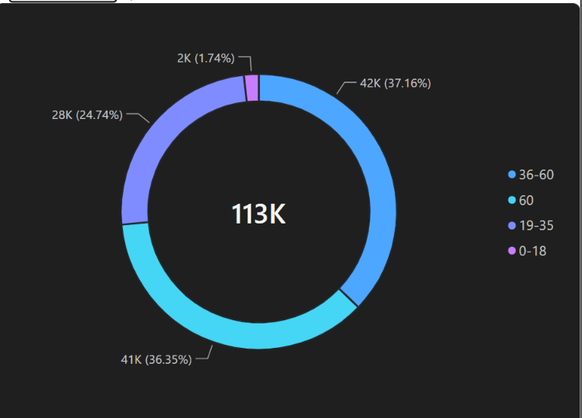

This visual provides an easy-to-understand view of the contribution of each age group to the overall hospital admissions.

6. Line Chart – Admission Trend

The Line Chart is used to display changes in hospital admissions over time.

* **X-Axis:** Date of Admission – Year and Month
* **Y-Axis:** Total Admissions

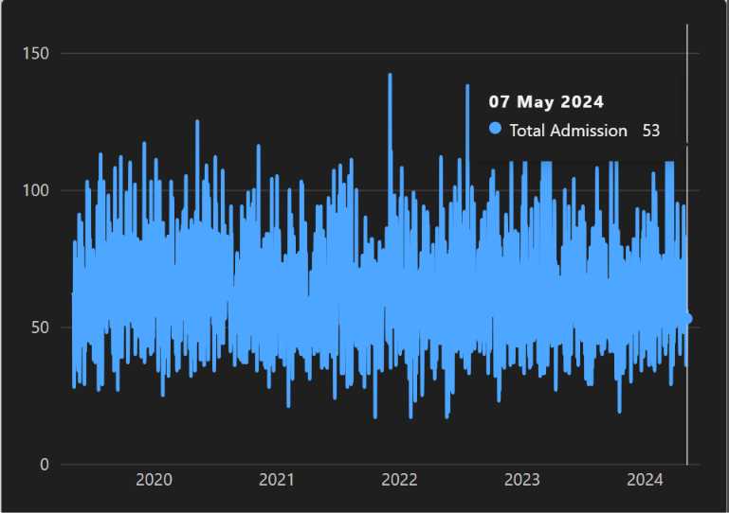

This visual helps identify admission patterns and changes over different months and years.

7. Slicer – Admission Type

An Admission Type slicer was added to make the dashboard interactive.

* **Field:** Admission Type
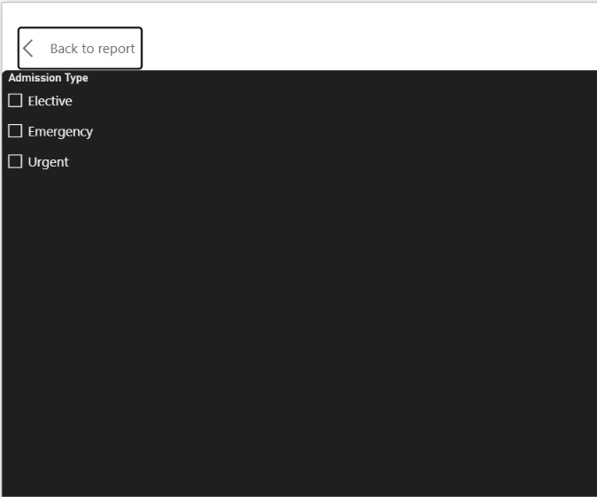

Users can select a particular admission type, and the dashboard visuals will update according to the selected filter.

8. Conclusion

The Week 6 dashboard provides a simple and interactive view of the healthcare dataset. The KPI cards summarize important hospital metrics, while the charts provide information about medical conditions, billing, patient age groups, and admission trends. The slicer allows users to interactively filter the dashboard and explore the data.

